// Account:
package transaction;
public class Account {
private int accountNumber;
private double balance;
public Account(int accountNumber, double balance) {
this.accountNumber = accountNumber;
this.balance = balance;
}
public void deposit(double amount) {
if (amount > 0) {
balance += amount;
System.out.println("Amount deposited: " + amount);
} else {
System.out.println("Invalid deposit amount!");
}
}
public void withdraw(double amount) {
if (amount > 0 && amount <= balance) {
balance -= amount;
System.out.println("Amount withdrawn: " + amount);
} else {
System.out.println("Insufficient balance or invalid amount!");
}
}
public int getAccountNumber() {
return accountNumber;
}
public double getBalance() {
return balance;
}
}
Output:
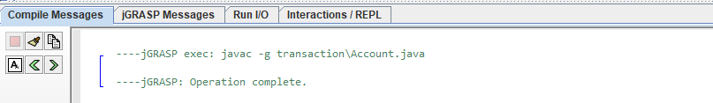

//Transaction:
package reports;
import transaction.Account;
public class TransactionReport {
public void generateReport(Account acc) {
System.out.println("\n----- TRANSACTION REPORT -----");
System.out.println("Account Number: " +
acc.getAccountNumber());
System.out.println("Current Balance: " +
acc.getBalance());
System.out.println("-----------------------------");
}
}
Output:
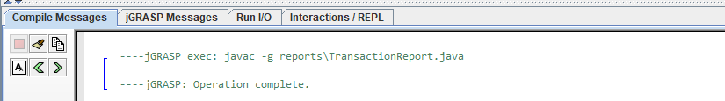

//Main:
import transaction.Account;
import reports.TransactionReport;
public class Main {
public static void main(String[] args) {
Account acc = new Account(1001, 5000);
acc.deposit(2000);
acc.withdraw(1500);
TransactionReport report = new TransactionReport();
report.generateReport(acc);
}
}
Output:


